Sarah Dubbert, Scott Howard, Joshua Koni, Mathewos Keller

Group 6

Design Prototype Images and Descriptions

**Boheme - Revamp**

Note - Boheme did not require us to create any new pages, and they already had a great page design in place. Below are photos of sections that we added to the pages.

Store Hours and Location Section

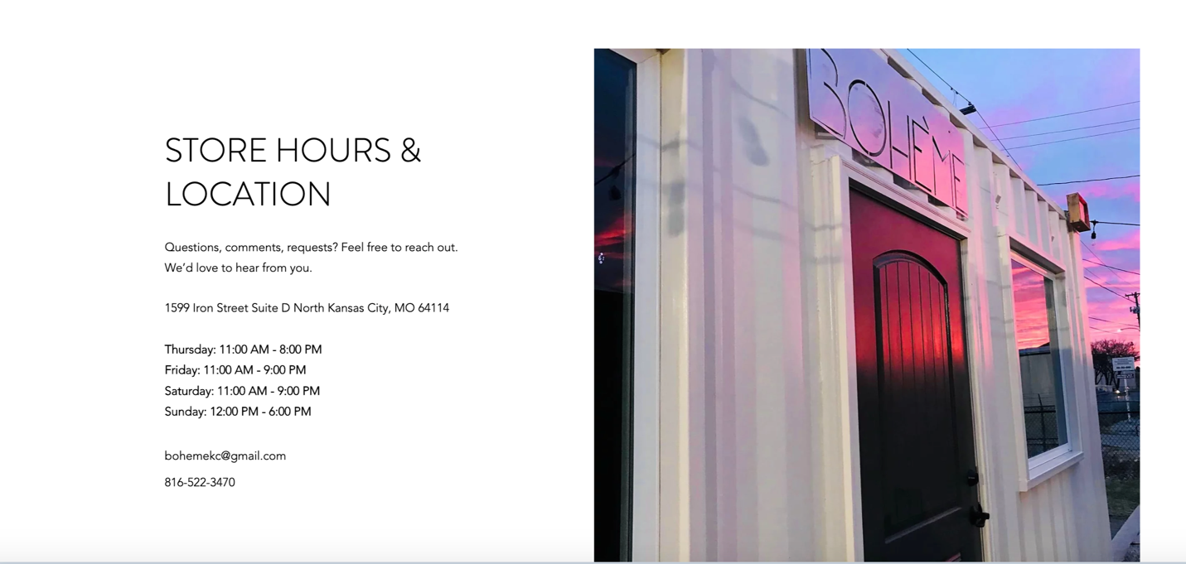

* We kept the simple white and black color scheme for the text, which allows the vibrant colors from the photo to pop
* The text is kept minimal and easy to access, at the bottom of the Home page

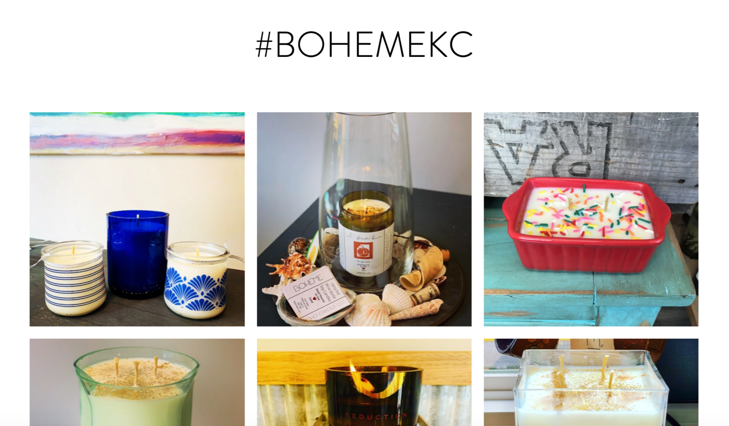Candles Page

* We added a hashtag for brand recognition on Instagram and Facebook
* The photographs were laid out in a grid to optimize space to be able to show off the range of products that Boheme sells

About Us Page

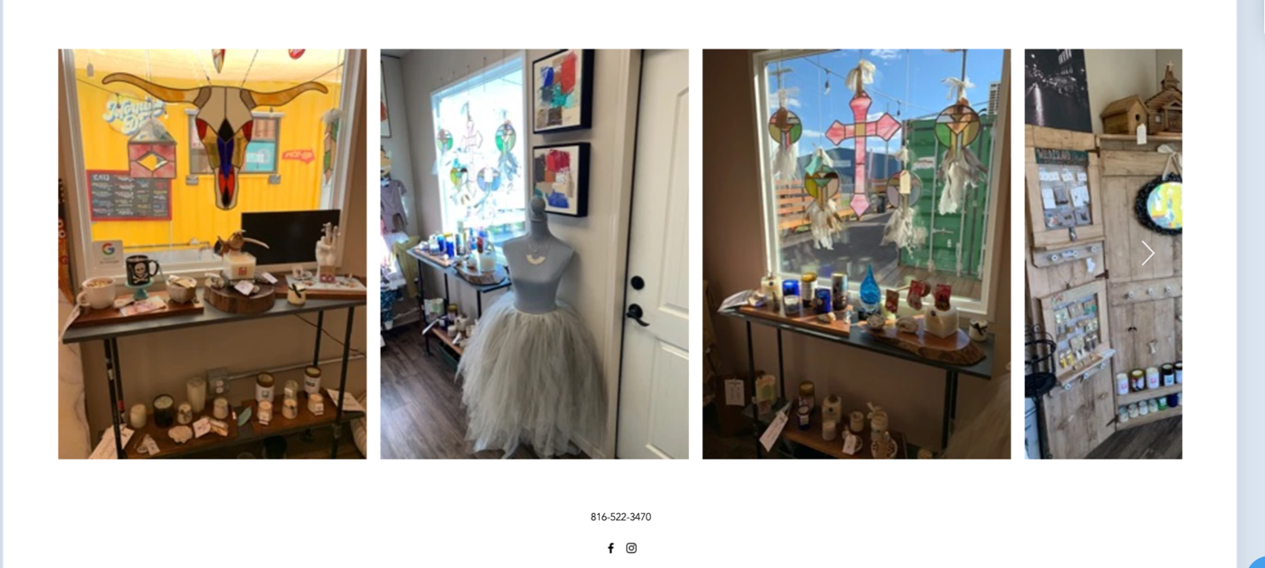

* We added photographs of the store so that the user can see what the store looks like
* The photographs have an arrow on the right so that when they hover over, they can see more photos

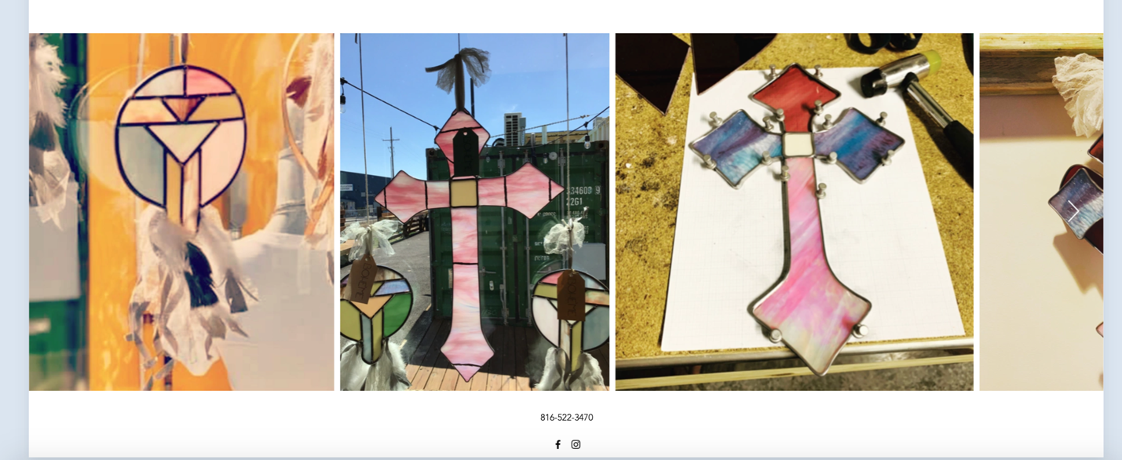Stained Glass Page

* This is a similar photo layout, where the user can scroll to see more product photos
* Placed on the bottom of the page so that users that are interested can see a range of different product styles